**Project Second Increment Report**

**Features developed for Increment2:**

1. Displaying places of a city, given destination from the user
2. Displaying places of Interest, given destination and Interest from the user
3. Displaying User reviews of a given place
4. Migrating from Local Storage to Mango DB

**Existing Services/REST API:**

<https://console.developers.google.com/google/maps-apis/>

**Detail Design of Features:**

**1. Wireframes& mockup:**

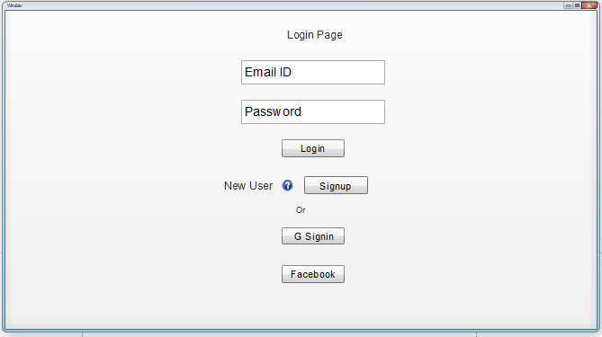

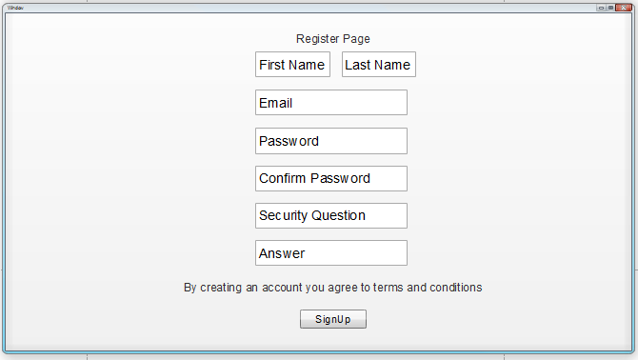

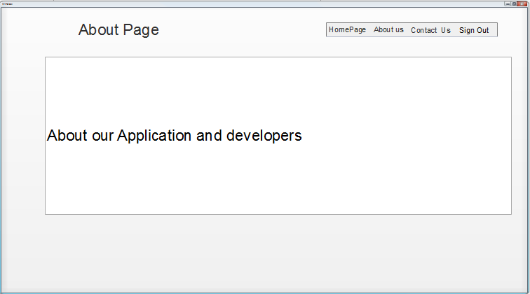

**Basic Functionality:**

First thing that a user should be seeing is a Login page, which has a username and password fields. Once the user provides his/her username and password he/she will be prompted to home page. Login can also be done using Google and Facebook.

User registration is required before logging into the application, on clicking Sign up here link in the login page, user will be prompted to Registration page, where user has to enter details like First name, Last name, Email id, Password, Conform Password, Security question and its Answer, a link to comply with Terms and conditions and then press Signup button.

After successful registration user will be asked to login to the application, after logging in user will be prompted to Home page. Home page consists of tabs to Contact Us, About Us pages where user can see the details of Admin and about the application details.

Any point of time user can logout from the system upon pressing Logout button.

**2. 1 Architecture diagram:**

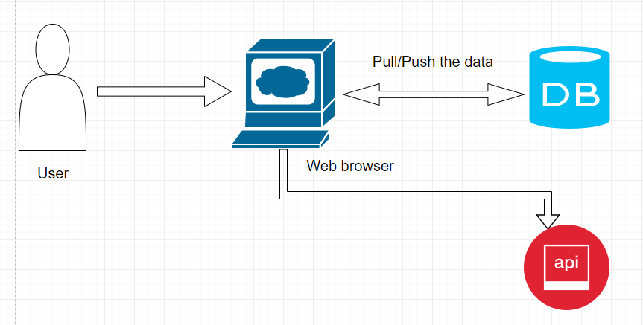

**2.2 Sequence Diagram:**

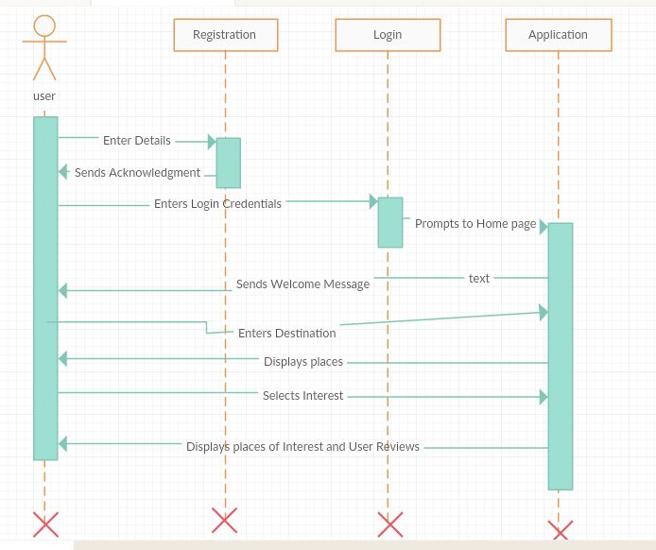

**2.3 Class Diagram:**

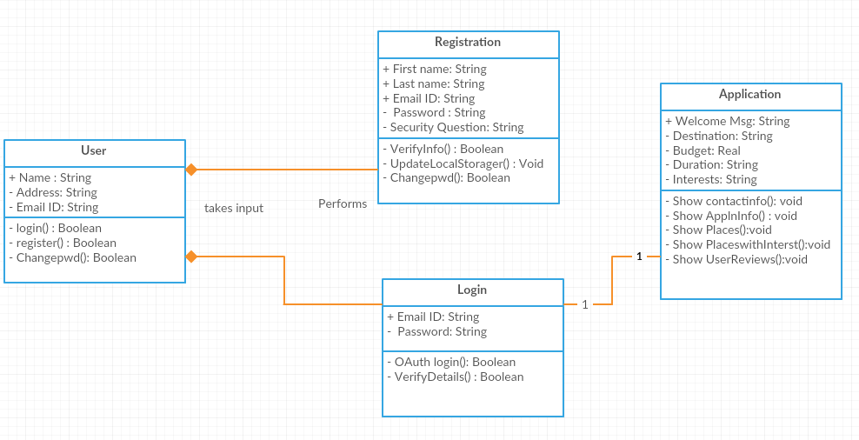

**3. User Stories**

**4. Testing**

**Travel Explorer – Web Application:**

**Login Page**

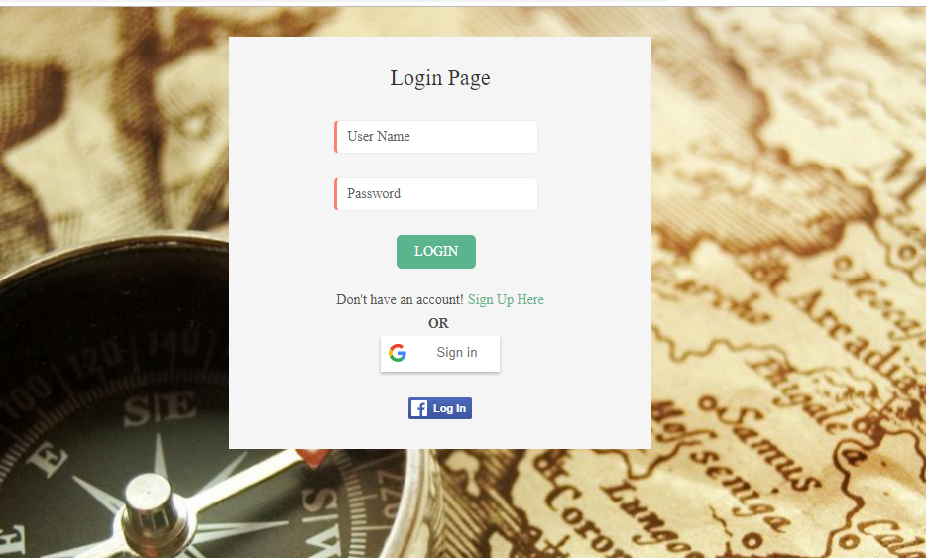

This is the first page that a user will be seeing upon reaching to website. Registration of a user is must before logging into the system. User can login with his credentials entered during Registration or can login using Google or Facebook authentication.

User will be successfully logged into the system if Credentials are right, if Username and Password does not match, user will be prompted that the credentials are wrong.

**Registration Page**

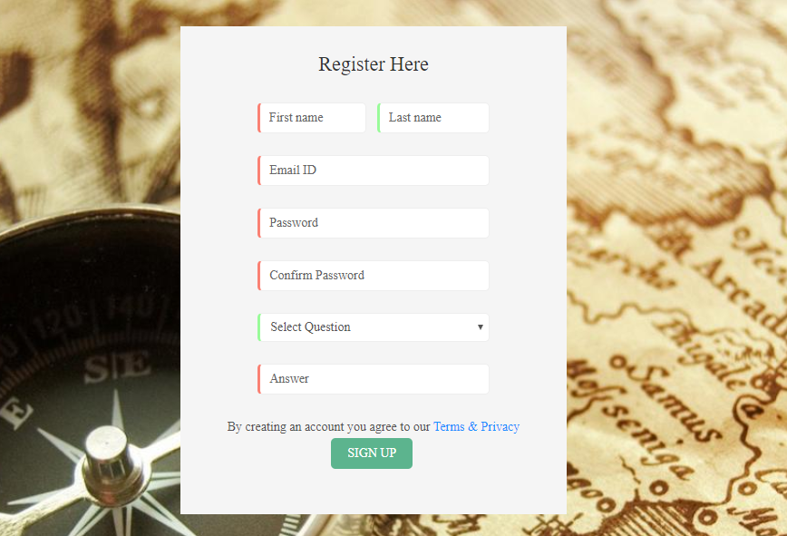

Upon clicking Sign Up Here link in the Login Page user will be prompted to Registration page,

here user should enter the details like First Name, Last Name, Password, Confirm Password,

Choose a Security Question, Answer for it and has to agree to Terms and conditions. Upon pressing Signup button user will be successfully registered.

User will now be prompted to Login Page, Some fields in the Registration Page are mandatory.

**Home Page**



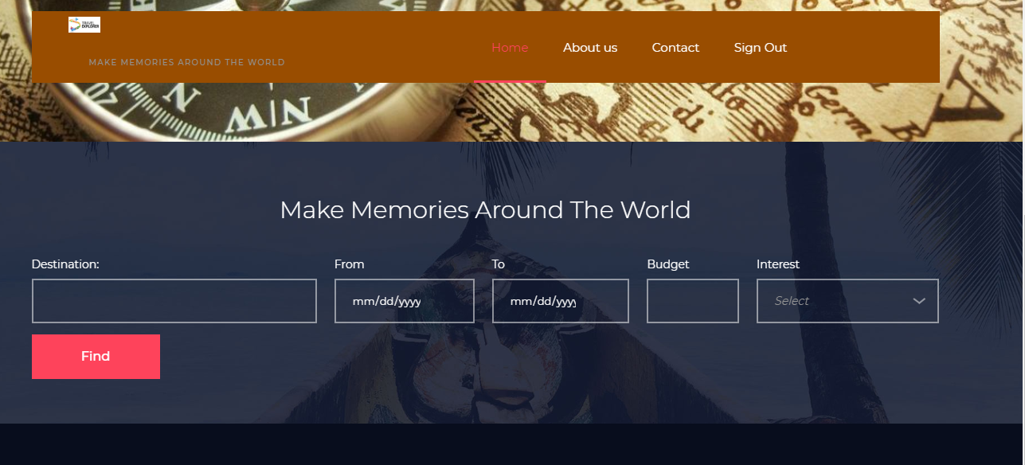

Home page consists of a Tab which links to Contact, About Us pages and to Logout from the System. It takes the User Input of Destination, from and to dates of the trip, Budget of the User and Interests.

**About Us**

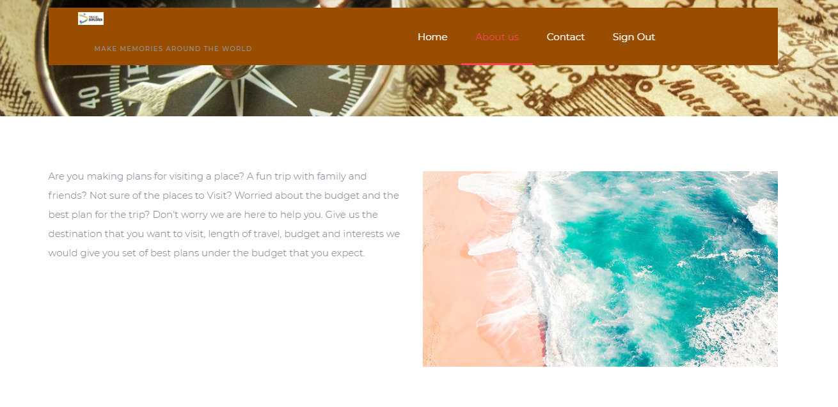

This page tells about why a user should be using our website.

**Contact Page**

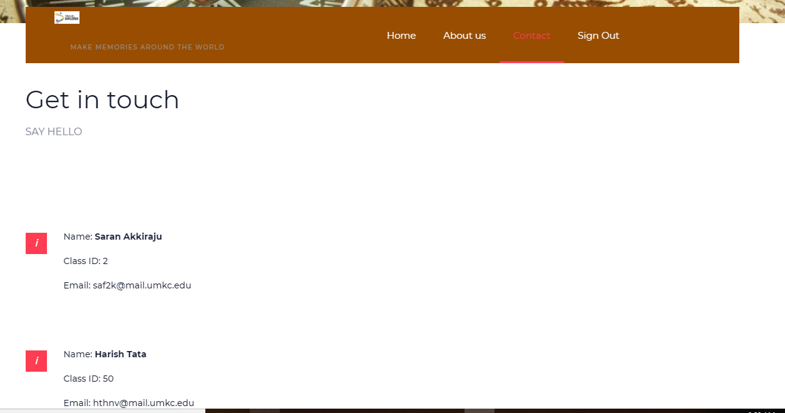

**Please find Github Wiki below:**

**Project Management**

**Board Issues:**

**ZenHub report:**

**Contribution chart:**

**References:**